Notes from Meetings
- Defining scope
o Is there scope to change the entire product architecture?
o Where do we stop?
§ Are we trying to

Define the scope in a way that we feel we can add value and quantitatively
- Measure air temperature
- Measure flow rate
- Measure humidity

What are the cooling requirements for maize?

Call with Benard Notes:
Reduces drying time for half if we dry at night as well
Blower is lacking a heating element
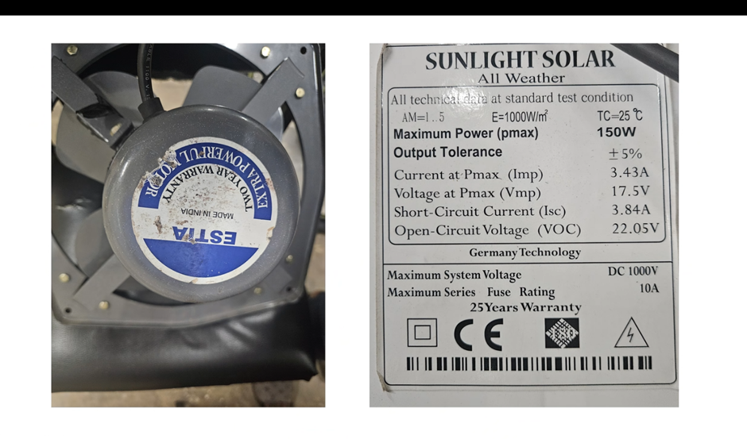
Faster we can dry the crop the more farmers that can use a single product
The aflatoxin predominantly exists in the soil so the maize is at greatest risk of contracting the fungus when it is left on the bare soil and becomes contaminated.
Rainy season when farmers are trying to dry their crops
8-12 hours of sunlight in a day
Bag is 200cm length 70cm wide and 25cm tall
Bottom side has a stronger black material to absorb heat, and the top material is clear – bit more susceptible
Benard is currently looking at sourcing new materials for the clear upper side of the bag for enhanced greenhouse effect and greater durability.
Normally 4-5cm of material in thickness (maybe mm)
Project is 9 months old
Manual mixing using a stick – after a couple of hours – also tried to develop an automated mixer. Not enough traction to make the grain roll. Trying to improve the system first before sorting our automatic mixing.
Many smallholder farmers have 1 acre of crops – 4 or 5 bags. The length of the bag can be scaled to allow for larger crop sizes. 5 bags = 90kg – fan is very powerful so can dry moisture over a long range.
The current controller is capable of varying the fan speed to balance keeping the bag inflated with keeping exhausted air at a reasonable amount.
At the tail end there are 2 exhaust holes which can be opened and closed. During the night the heat needs to be trapped in, so the exhaust holes are closed.
At night, it is key that as much energy is retained for useful work as possible.
Looked at a hair dryer for inspiration – there is potential here. Spoken about but not tried – don’t know what materials are used. Same for bullet point 2.
The key aspect to the hairdryer inspiration was the ability to control and vary the heat output, probably useful for ensuring the air is close to ambient temperature by the time it leaves the bag.
Potential in bullet point 3
Grain is heavy – can’t assume the floor is flat – but equal heating is definitely a problem

